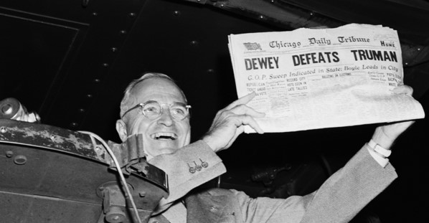

PRESIDENT TRUMAN PRESENTATION & POT LUCK LUNCH
MARCH 18, 2018 AT FORNEY MUSEUM of TRANSPORTATION, 4303 BRIGHTON BLVD, DENVER, CO 80216
Join the Rocky Mountain Region WPC Club and other area Mopar Clubs for a potluck lunch and presentation beginning at 11:30. Lunch will start at 12:30 and the presentation at 1:30. Please enter through the side door in the rear parking lot. If you bring a collector car you can park in the front lot. Please bring either a meat or side dish or dessert to share. Chicken, soft drinks, coffee and eating utensils/plates will be provided. Admission to the lunch and presentation is $5. (NOTE: This does not include admittance to the museum floor.)
Local historian Lloyd Barger will give an entertaining and educational program about President Harry Truman. Mr. Barger will tell us about Truman’s love of Chrysler cars and touring the U.S. to advance his political career. Nearly all the cars he owned were Plymouths, Dodges or Chryslers and pictures and stories of those vehicles will be presented. The second part of the program will detail how Truman’s love of trains and train travel resulted in the most historic election upset in U.S. history. Pictures and fascinating background detail the 31,700-mile whirlwind Whistle Stop Tour held during his campaign in 1948. Dressed as Mr. Truman, Barger will hold a Presidential press conference at the end of the program so attendees can ask any questions about Truman’s political life. Mr. Barger is a winner of the National Freedom Foundations Medal for public speaking and was recently awarded a commemorative diploma from Truman State University in Missouri.
